Part 1
E/ER diagram
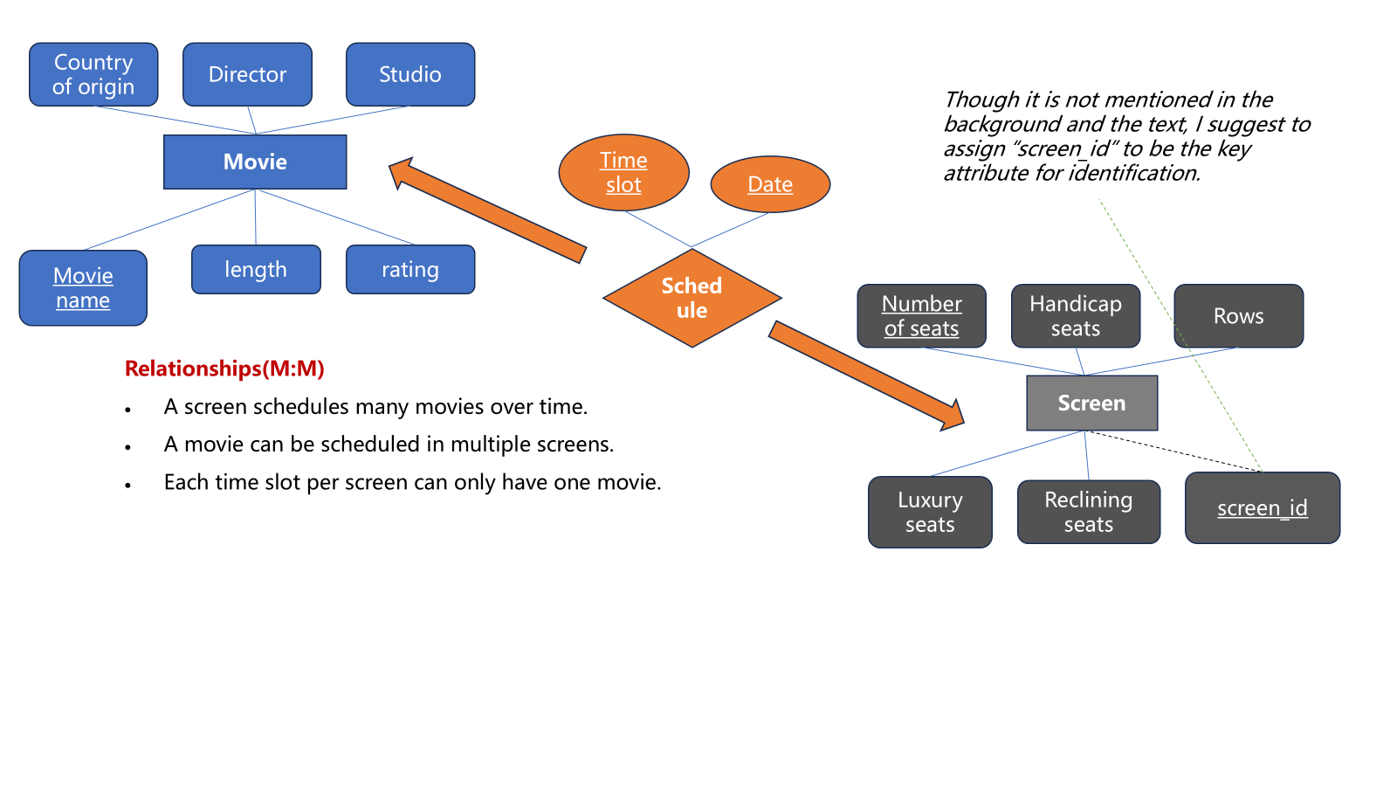
Tables used in the database
- Movie: movie name, length, genre, rating, country, director, studio
- Screen: screen id (or number of seats), handicap seats, rows, luxury seats, declining seats
- Schedule: screen_id(or number of seats), movie name, date, time slot
3 queries with the database
1. Which movies are scheduled on Saturday evening?
2. Which screen has the largest seating capacity?
3. Which movie is going to run for most times over next week?
1 query that requires additional attributes：Which movies generated the highest revenue last week?
This requires ticket sales data, which needs attributes ticket_price and num_of_tickets_sold under the the Schedule table.

Part 2

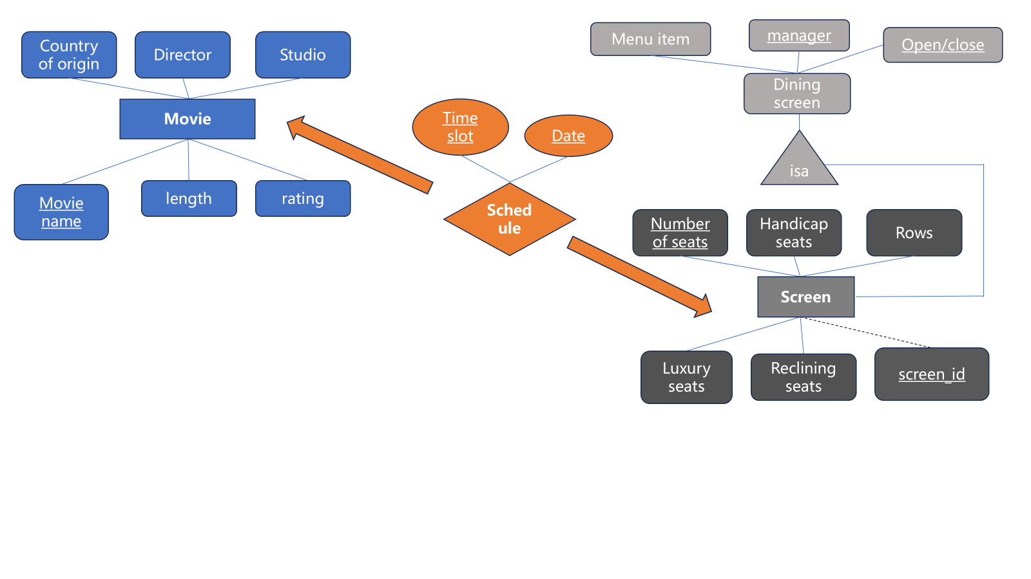

Part 3
